**CTP FIX Gateway User Manual**

|  |  |  |  |
| --- | --- | --- | --- |
| Company | Shanghai Futures Information Technology Co. | Document No. |  |
| Title | CTP FIX Gateway Introduction | Document Version | V1.2.0 |
| Create |  | Begin Date | 2017.11 |
| Update | Message Explanation: No.13 and No.15 | Update Date | 2018.06 |
| Update | Message Explanation: No.31 | Update Date | 2018.09 |
| Update | Message Explanation: No.21 and No.26 | Update Date | 2018.09 |
| Update | Message Explanation: No 16 (1) | Update Date | 2019.01 |
| Update | Penetrating Supervision：Add Message Explanation No.32, Update 4.1.1 and 4.2.1 | Update Date | 2019.03 |
| Update | 1). Message Explanation is divided into four parts and some has been modified.2). Add a new section 5.1.2. | Update Date | 2019.03 |
| Update | Add chapter 4.0: Flow chart of the client authentication and login under penetrating supervision. | Update Date | 2019.04 |
| Update | Add description of Terminal direct connection mode | Update Date | 2019.05 |
|  | | | |
| Title | CTP FIX Gateway Introduction | Document Version | V1.2.1 |
| Update | 1).The chapter 5 add option business with new sections 5.8~5.15; 2).Update the flow chart of 5.2 and 5.3. | Update Date | 2019.11 |
| Review |  | Confirm Date |  |

Contents

1、Background 4

2、System Schematic Diagram 4

3、Message Explanation 5

3.1 Communication and Message 5

3.2 Message Sequence 8

3.3 Trading 11

3.4 Penetrating Supervision 14

4、Session Layer 15

4.0 Flow Chart of the Client Authentication and Login under Penetrating Supervision 15

4.1 Client Authentication of Penetrating Supervision (except for FIX market data Gateway) 16

4.1.1 Common situation（tag141-ResetSeqNumFlag is null or value is 'N'.） 16

4.1.2 Client applies for sequence reset (succeed or fail) 17

4.2 Penetrating Supervision Login (except for FIX market data Gateway) 18

4.2.1 Common login situation under different modes（tag141-ResetSeqNumFlag is null or value is 'N'.） 18

4.2.2 Client applies for sequence reset (succeed or fail) 23

4.2.3 Tag34-MsgSeqNum in the message is too high 24

4.3 Logout 26

4.4 Password Update 27

4.5 Test Request 28

4.6 Resend Request 29

5、Business Layer 31

5.1 NewOrderSingle 31

5.1.1 NewOrderSingle: Non-split 33

5.1.2 NewOrderSingle: Split 35

5.2 OrderCancelRequest 38

5.3 OrderCancelReplaceRequest 40

5.4 OrderStatusRequest 42

5.5 SecurityDefinitionRequest 43

5.6 MultilegOrders 44

5.7 MarketDataRequest 45

5.8 MassQuote 47

5.9 QuoteCancel 49

5.10 QuoteRequest 51

5.11 NewOrderSingle-OptionSelfClose 52

5.12 OrderCancelRequest-OptionSelfCloseAction 53

5.13 PositionMaintenanceRequest-ExecOrderInsert 54

5.14 PositionMaintenanceRequest-ExecOrderAction 55

5.15 QuoteStatusRequest 56

# 1、Background

In the context of the acceleration of trade globalization, the INE (International Energy Exchange) introduced the crude oil futures product, SC, to the public. In order to facilitate foreign investors to participate in China's futures trading, Shanghai Futures Information Technology Co. provides the FIX (Financial Information eXchange) Gateway to bridge FIX user to the CTP (Comprehensive Trading Platform), the most popular futures broker trading system in China.

The FIX protocol is a financial information exchange protocol, or data exchange standard designed for real-time securities and financial electronic transactions. With the development of economic globalization and intense interconnections between major exchanges, the FIX protocol was jointly launched by several major investment banks of the US, such as Fidelity Fund, Goldman Sachs, Merrill Lynch and JP Morgan. The FIX protocol gained its popularity among the major investment banks immediately after its debut. In recent ten years, the FIX protocol has been widely adopted as a universal interface protocol in global market. About three quarters of financial software products use the FIX protocol. Different countries have developed their own localized application protocols based on the FIX protocol to meet their market rules.

With the above background, the CTP FIX Gateway has two major goals. Firstly, it must be able to accept and analyze requests from foreign trading terminals that use the FIX protocol. Secondly, it must be able to transform responses from the CTP into the format of the FIX protocol and forward to those trading terminals.

# 2、System Schematic Diagram

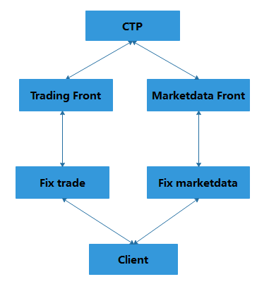

Figure1

# 3、Message Explanation

## 3.1 Communication and Message

1. The system is based on FIX (Financial Information eXchange) version 4.2.
2. The FIX message uses standard headers and trailers. Please refer to the document, “CTP FIX Interface and Quotation”, for details about the tags.
3. The FIX Gateway includes two parts: the FIX market data Gateway and the FIX trade Gateway. Both are referred to as "FIX Gateway" interchangeably in this system. The FIX trade Gateway supports requests for resending messages (tag35-MsgType=2) from trading terminals. The maximum number of response messages is 2500 for a single request. The FIX trade Gateway also supports client authentication messages (tag35-MsgType=A, tag116-OnBehalfOfSubID=12304) and update user password request messages (tag35-MsgType=A, tag116-OnBehalfOfSubID=12298) from trading terminals. However, the FIX market data Gateway does not support those messages. Except for the difference of request messages above, these two Gateways have identical message sets.
4. For one FIX Gateway, multiple sessions are not allowed to be online at the same time for one trading terminal.
5. Determination of the FIX message flow:

According to values of the field tag49-SenderCompID and the field tag56-TargetCompID, the FIX Gateway can determine if the message is from the client to the server, or the reverse. For example, if the value of tag49-SenderCompID is a ClientID and the value of tag56-TargetCompID is a BrokerID, then the message is from a client to the server. Otherwise, the flow direction is reverse. In addition, the client above refers to the trading terminal, and the server above refers to the FIX Gateway.

* tag49-SenderCompID：this field is filled with a ClientID in the request message or a BrokerID in the response message.
* tag56-TargetCompID：this field is filled with a BrokerID in the request message or a ClientID in the response message.

1. The tag35-MsgType is used to determine the FIX message type. However, for the FIX Gateway, the tag35 is not enough. In order to further specify the purpose of a message, the FIX Gateway uses the tag116-OnBehalfOfSubID as a supplement. The detailed definitions are as follows:

Table 1

|  |  |  |
| --- | --- | --- |
| **The request message from the trading terminal** | | |
| **Tag35** | **Tag116** | **Instruction** |
| A | 12304 | Client authentication request |
| 12324 | Submit user system information |
| 12288 | User login request |
| 12298 | Update user password request |
| V | 17409 | Subscribe market data request |
| 17411 | Unsubscribe market data request |
| D | None | General new order request |
| 16436 | Option Self-Close request |
| F | None | General order cancel request |
| 16438 | Option Self-Close action |
| **The returned message from the FIX Gateway** | | |
| **Tag35** | **Tag116** | **Instruction** |
| A | 12305 | Client authentication success response |
| 12289 | User login success response |
| 131081 | User login failure response |
| 131082 | Submit user system information success response |
| 12299 | Update user password success response |
| 131080 | Update user password failure response |
| W | 17410 | Subscribe market data response |
| 17412 | Unsubscribe market data response |
| 8 | 61441 | Return order response |
| 61442 | Return trade response |
| 16437 | Option Self-Close response |
| 61473 | Option Self-Close return |
| 9 | None | Order cancel replace request was rejected |
| 16439 | Option Self-Close action response |
| 61457 | Option Self-Close action error return |

1. Value ‘3’ of tag35-MsgType in a request message is not supported.
2. The association between a request message to and a response message from a FIX Gateway:

* When the value of the tag57-TargetSubID in a response message is equal to the value of tag50-SenderSubID in a request message, then it indicates that these two messages are corresponding to each other.
* If there are several response messages in which the values of tag57-TargetSubID are the same, then they are all corresponding to one request message with the same value of tag50-SenderSubID.
* In addition, the data type of tag50-SenderSubID is integer. And in the response message, the default value for tag57-TargetSubID is zero.

1. The FIX Gateway does not return any response message after dealing with a sequence reset request from the trading terminal successfully.
2. The trading terminal can set the heartbeat interval through the tag108-HeartBtInt field in authentication and login request messages. A valid heartbeat interval ranges between [30,60] seconds, or it will be rejected by the FIX Gateway. In addition, for the same connection, the FIX Gateway will accept the latest heartbeat interval setting. For example, if the trading terminal sends an authentication request with a login request afterwards, and the values of tag108-HeartBtInt are different in those two messages, the FIX Gateway will accept the heartbeat interval set of the login request.
3. In the update user password request, passwords (both old and new) cannot contain character ':' in the tag96-RawData field. Requests violating this rule may result in unpredictable results.
4. When the trading terminal sends a query request message, the FIX Gateway will return a query response if the CTP system has an exact result that meets the query criteria. Otherwise, the terminal will not receive any query response. In addition, the trading terminal may be forced to logout when the CTP query system is not ready. In this situation, the tag58-text field will show the reason of logout with the message "FIX: CTP Query Engine not ready".
5. The application of the session layer rejection (tag35-MsgType=3) and the business layer rejection (tag35-MsgType=j) :

1）The session layer rejection: Session Layer Rejection happens when the request messages violate the session layer rules. The causes could be unsupported protocol version, the missing of required tags, empty or incorrect value of one tag, resending time is earlier than the original sending time, and so on.

2) The business layer rejection: Business Layer Rejection happens when request messages are accepted by the session layer but rejected by the business layer. Possible causes could be unsupported request message type, the missing of required tags, incorrect InstrumentID, and so on.

1. The rules of login status validation:

1）After the trading terminal passes the CTP authentication, the FIX Gateway will reject authentication request messages afterwards.

2）After the trading terminal logs in the CTP successfully, the FIX Gateway will reject authentication and login request messages afterwards.

3）Before the trading terminal logs in the CTP successfully, the FIX Gateway will only accept authentication, login, logout, and update user password request messages from the terminal. For update user password requests, there are only three situations suitable for this rule. They are: login for the first time[1], expiration of passwords[2], and expiration of weak passwords[3].

1. Additional explanatory information formats:

If the explanatory information is returned from the CTP, then the format of tag58-Text will be "ErrorID=**, ErrorMsg=CTP:**". If the explanatory information is returned from a FIX component, then the format of tag58-Text will be "FIX:**".

1. In order to monitor the communication link, the FIX Gateway sets a timer, just as the following:
2. If the FIX Gateway does not receive a request message from the terminal between 1.2 times and 2.4 times of the heartbeat interval, it will send a test request message (tag112-TestReqID="Test") to the terminal.
3. If the FIX Gateway does not receive a request message from the terminal over 2.4 times of the heartbeat interval, it will break the connection.
4. If the FIX Gateway does not receive a request message from the terminal between 1.0 times and 1.2 times of the heartbeat interval, it will send a heartbeat response to the terminal.

## Message Sequence

1. The request message from a terminal will be discarded in two situations. That is to say, the FIX Gateway will neither return any response nor increment the request serial number. These two situations are as follows:

1） Before the corresponding response of authentication or login request returns to the trading terminal.

2） Before the logout response returns to the trading terminal while the FIX Gateway has already forced the user to logout.

1. Criteria for judging whether the FIX Gateway will check that the request serial number (tag34-MsgSeqNum) is too high or too low:

Table 2

|  |  |  |
| --- | --- | --- |
| **FIX Message** | | Whether or not the tag34-MsgSeqNum will be checked for too high or too low |
| **Tag35** | **Tag116** |
| A | 12304 (Client authentication request) | Not check for too high, but check for too low  (Please refer to No.4 below for exceptions) |
| 12288 (User login request) |
| 4 | (Sequence request) | Whether to check or not is due to the value of tag123-GapFillFlag field. The FIX Gateway will check whether the request serial number is too high or too low when the value is 'Y', and no check when the value is 'N'. |
| 2 | (Resend request) | Neither check for too high nor check for too low |
| 5 | (Logout request) |
| 0 | (Heartbeat request) | Check for too high and too low both . |
| 1 | (Heartbeat test request) |
| A | 12298 (Update user password request) |
| others | (Business request) |

1. When the value of tag34-MsgSeqNum in the request is higher than the serial number expected for the client, the Gateway will process the message as follows:

1）According to Table 2 above，for a request message which is required to be checked, the FIX Gateway will send a command asking the trading terminal to resend a specified range of messages. Please note that these resent messages must contain value 'Y' for tag43-PossDupFlag in the standard header.

2）According to Table 2 above，for a request message which is not required to be checked, the FIX Gateway will not check tag34-MsgSeqNum and allow the client to continue with its next operation. For example, a user can login to the CTP system successfully with a too high tag34-MsgSeqNum.

1. When the value of tag34-MsgSeqNum in the request is lower than the serial number expected for the client, the Gateway will process the message as follows:
2. According to Figure 2 below, for a request message which is required to be checked, the Gateway will process as follows:

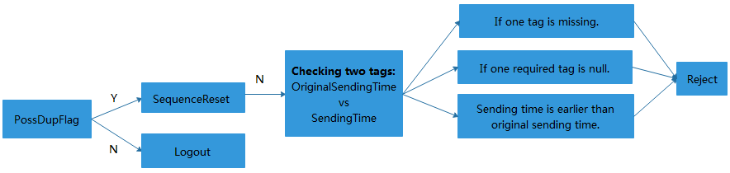

Figure 2

* Firstly, the FIX Gateway examines the field of tag43-PossDupFlag. The user will be forced to logout when its value is 'N'.
* Secondly, in the case that the value of tag43-PossDupFlag is ‘Y’, the FIX Gateway will repeatedly examine the value of tag35-MsgType until it equals '4', that is to say, when it's not a reset sequence request message.
* Then the FIX Gateway must further check the send time (tag52) and the original send time (tag122). There are three situations that lead to rejections after this further checking. They are: one tag is missing; one required tag is null; the send time (tag52) is earlier than the original send time (tag122).

2）According to Figure 2 above, for a request message which is not required to be checked, the FIX Gateway will let the client pass the check and continue with the next operation. For example, the clients can logout the FIX Gateway with a too low request serial number.

1. For the same connection, the FIX Gateway only permits the trading terminal to successfully reset sequence number once through the authentication or login request message. In the request message, the values of tag141-ResetSeqNumFlag and tag34-MsgSeqNum must be 'Y' and '1', respectively. Otherwise, that request message will be rejected. At the same time, this message will not be checked whether the serial number is too low. The phrase 'reset sequence number' above means that these two serial number lists that are maintained by the FIX Gateway will be both reset to '1'. These two serial number lists are the client request serial number and the server response serial number.
2. The increment rules of the client request serial number：

Table 3

|  |  |  |
| --- | --- | --- |
| **FIX Message** | | **The incremental rules of the request serial number (tag34-MsgSeqNum)** |
| **Tag35** | **Tag116** |
| A | 12304 (Client authentication request) | 1. The serial number of the client request and the value of tag34-MsgSeqNum in the next request message will both increase by one when the trading terminal authenticates and logs in to the CTP successfully. 2. The serial number of the client request and the value of tag34-MsgSeqNum in the next request message will remain unchanged when the trading terminal fails to authenticate or login to the CTP. |
| 12288 (User login request) |
| 4 | (Sequence request) | 1. If the client successfully resets the sequence serial number, then the value of tag36-NewSeqNum will be assigned to the client request serial number and the tag34-MsgSeqNum. 2. If the client fails to reset the sequence serial number, then the serial number of the client request and the value of tag34-MsgSeqNum in the next request message will remain unchanged. |
| A | 12298 (User password update request) | Except for the scenarios above, the serial number of the client request and the value of tag34-MsgSeqNum in the next request message will both increase by one, as long as the tag34-MsgSeqNum of this message is consistent with the serial number of the client request, whether the request was successful or not (rejected or forced to logout). Otherwise, both of them will remain unchanged. |
| 2 | (Resend request) |
| 5 | (Logout request) |
| 0 | (Heartbeat request) |
| 1 | (Heartbeat test request) |
| others | (Business request) |

## 3.3 Trading

1. For the first login of a trading day, each user is required by the CTP system to confirm the settlement bills of the previous trading day. The FIX Gateway does not help users to confirm the settlement bills automatically by default. However, users can apply to the broker company for the FIX Gateway to confirm the bills automatically. Nevertheless, it’s worth noting that the user won’t get relative information of the settlement bills and must be responsible for all risks caused by the auto-confirmation. In addition, if the user's role is an *operator,* but not an *investor*, the CTP system will not require the user to confirm the bills.
2. During trading time, after the user logs in successfully, he will receive all his residual order and trade response messages that he fails to receive in the last connection of the same day, if any. The user shall wait until receiving all his order and trade response messages, before submitting any order request through the FIX Gateway. Otherwise, it’s possible that the FIX Gateway would put in a wrong value when the field of tag77-OpenClose is null in the request message.
3. The uniqueness of orders can be determined in two ways:

An order can be uniquely identified by these three fields put together, tag11-ClOrdID, tag20004-FrontID, tag20005-SessionID. The data type of tag11-ClOrdID is integer. In addition, for the same connection, the tag11-ClOrdID is required to be ascending and larger than the maximum that the Gateway maintains. Otherwise, the request message will be rejected by the Gateway.

An order can be uniquely identified by these two fields put together, tag37-OrderID and tag207-SecurityExchange. The data type of tag37-OrderID is integer and its value is provided by exchanges. Each exchange maintains a sequence number for tag37-OrderID.

The methods to uniquely identify an order could be used in the following usage scenarios:

The cancel or cancel/replace order request;

Rebuilding a new order or not according to the order response.The FIX Gateway will first use method 1) then method 2) to find the original order. If both methods failed to find the order, the FIX Gateway will conclude that it doesn’t exist at all.

1. For immediate orders, the field of tag110-MinQty is invalid.
2. For a response message whose value of tag35-MsgType equals '8', the tag17-ExecID is meaningful as the TradeID only when the value of tag116-OnBehalfOfSubID equals ‘61442’ and tag150-ExecType equals 'F'. Otherwise, its default value is zero.
3. For a response message whose value of tag35-MsgType equals to '8', when the value of tag37-OrderID is zero, it means that the corresponding request message has already been checked by the CTP and submitted to the Exchange. When the value of tag37-OrderID is larger than zero, it means that the corresponding request message has already been submitted to the Exchange and the value of tag37-OrderID is the actual OrderID.
4. For an order with tag77-OpenClose being null, the FIX Gateway processes it as follows:

**Condition 1**: the parameter of the order is set to be non-split (the parameter ReverseOpen is set to 1 in FIXfront_mt.ini)

If the user owns a position (note: not an order) opposite to the direction of the order:

1. When the volume of the order is smaller than or equal to the opposite position, the FIX Gateway will treat this order as a close position order of the volume declared.
2. When the volume of the order is greater than the opposite position, the FIX Gateway will treat it as an open position order of the volume declared.

Note: If the user owns both historical position and today’s position of the Shanghai Futures Exchange, the new order will be split even if the parameter ReverseOpen is set to 1. For example: A user holds a historical long position of 3 hands and a current long position of 2 hands, and sends an order to sell 4 hands. The FIX Gateway should handle it as an order of selling 4 hands because the order volume 4 is smaller than the opposite position (3+2). However, if the historical position and today’s position belong to the Shanghai Futures Exchange, the FIX Gateway would split the order into two selling orders: one is a close historical position order of 3 hands, the other is a close today position order of 1 hands. This does not fall in the FIX split order situation. It is caused by the special rules of the Exchange.

**For example**：

1. Initially, an investor holds 5 hands of short position of sc1412. During the trading time, the investor sends an order to buy 4 hands of sc1412. Since 5>4, the FIX Gateway will handle it as a close position order of buying 4 hands.
2. Initially, an investor holds a short position of 5 hands of sc1412. During the trading time, the investor sends an order to buy 10 hands of sc1412. Since 5<10, the FIX Gateway will handle it as an open position order of buying 10 hands.
3. Initially, an investor holds a short today position of 5 hands of sc1412 and a short historical position of 5 hands of the same security. During the trading time, the investor sends an order to buy 8 hands of sc1412. Since 8<(5+5), FIX Gateway will divide this order into 2 parts. One is a close historical position order of buying 5 hands, and the other is a close today position order of buying 3 hands.

**Condition 2:** the parameter is set to split the order (the parameter ReverseOpen is set to 0 in FIXfront_mt.ini)

If a user already owns an opposite position of the same security, the FIX Gateway will send a close order whose volume is min(volume of the order, volume of the opposite position).

For example:

1). When the volume of the order is greater than the opposite position, the order will be divided into two parts. The first part is a close position order with the same volume of the opposite position. The second part is an open position order with the residual volume.

2). When the volume of the order is smaller than the opposite position, the FIX Gateway will handle this order as a close operation to the opposite position. If the user sends an order again with the same direction as the preceding order before he receives the response, the FIX Gateway will send a close order to the opposite position, with a volume of min (volume of the order, original volume of the opposite position - the volume of the preceding order).

**The processing rules of the FIX Gateway**:

The following description concerns one investor with one specific security. Suppose that the volume of the order is 'vol' and the volume of the opposite position is 'oppvol'.

1. If vol > oppvol > 0, the FIX Gateway will split the order into two parts: a close position order with a volume of oppvol, and an open position order with a volume of (vol – oppvol).
2. If oppvol >= vol, the FIX Gateway will handle this order as a close order with a volume of vol.

**Examples**：

1. Initially, the investor does not hold a short historical position of instrument sc1712. During the trading time, the investor sends an order to buy 10 hands of sc1712. Before receiving the response, the investor sends another order to sell 5 hands of sc1712. In this case, the FIX Gateway will send an open order of selling 5 hands of sc1712.
2. Initially, the investor holds 10 short hands of historical position of instrument sc1712. During the trading time, the investor sends an order to buy 15 hands of sc1712. As min (15, 10) =10, the FIX Gateway will split this order into two parts, a sell short order with a volume of 10 and a buy long order with a volume of 5.
3. Initially, the investor holds 10 short hands of historical position of sc1712 security. During the trading time, the investor sends an order to buy 3 hands of sc1712. As min (3, 10) =3, the FIX Gateway will treat this order as a 3-hand close short position order，and then the remaining short position is 7 hands. If the investor sends another order to buy 10 hands of sc1712 now, as min (10, 7) =7, the FIX Gateway will divide this order into two parts: one 7-hand close short position order, and one 3-hand open long position order.
4. For the FAK (Fill And Kill) order (tag59-TimeInForce=3), the minimum volume tag110-MinQty is valid only when the tag77-OpenClose is not null. Otherwise, the order will be traded with any volume.
5. The format of the 'Price' data type (e.g. tag44-Price) refers to those in market data published by the Chinese Exchanges.
6. For conditional orders, the FIX Gateway processes as follows:
7. Firstly, the investor's position will not be frozen when sending the conditional order request message. Then the CTP will verify the legitimacy of the message.
8. If the message fails the verification, the same as ordinary orders, the CTP will return an error message through the callback function OnRspOrderInsert, and the FIX Gateway will return the response message through tag35-msgtype=8 as well.
9. If the message passes the verification of the CTP, this conditional order will be stored in the order list and its status will be showed as "not triggered". When certain trigger conditions are met, its status would be updated to "triggered". The status message will be returned through the callback function OnRtnOrder, and the FIX Gateway will return the response message through tag35-msgtype=8 as well.
10. When the trigger condition is met, the CTP will treat this conditional order as a new ordinary order and a new tag11-ClOrdID will be assigned at the same time. Tag20004-FrontID and tag20005-SessionID are set to 0 by default. Then, the CTP will verify the legitimacy of the newly generated order. If the verification fails, the error message is returned by the callback function OnRtnErrorConditionalOrder, and the FIX Gateway will return the response message through tag35-msgtype=8 as well.
11. After the conditional order is triggered, the FIX Gateway will treat the new order generated by CTP as a non-Gateway order. Then it will rebuild an order according to the first response message. And the investor's position will be frozen at this moment. The order is rebuilt to support the subsequent cancellation or replacement.
12. The touch order and touch profit order of the DCE Exchange are sent directly to the Exchange and triggered by the Exchange as well. So their processing procedure is different from the above statement.
13. If the Order Cancel Request succeed, two messages will be returned: one is from the CTP with tag11-ClOrdID equals the tag11-ClOrdID of the original order-reference, the other is from the FIX with tag11-ClOrdID equals the tag11-ClOrdID of the OrderCancelRequest.
14. For each session, after receiving the order fill notice (35=8, tag116=61442) and saving it, the accumulated transaction quantity and remaining quantity would be calculated respectively.
15. When a single order is cancelled repeatedly, if the second order cancellation request is submitted for the same order before the first order cancellation return has not been received, the client will receive two cancellation returns of the same tag11, one is cancellation success and the other is cancellation failure.

## 3.4 Penetrating Supervision

The system processes Penetrating Supervision as follows

1. Customers are divided into two categories according to whether they are supervised or not. For supervised customers, the FIX Gateway will collect the terminal authentication information and report it to the monitoring backend in an encrypted message. According to the customer's terminal connection type, the FIX Gateway picks one of the three connection modes below:

* Terminal direct connection mode: When an investor logs in to the FIX Gateway, the Gateway will establish an independent connection for him, referred to as Terminal direct connection mode. In this mode, the Gateway will collect client’s IP information automatically.
* Repeater multi-to-multi mode: When a repeater logs in to the FIX Gateway as a single investor, the Gateway will establish an independent connection for each login user, referred to as repeater multi-to-multi mode. In this mode, the user is required to fill in his client’s IP information.
* Repeater one-to-multi mode: When a repeater logs in to the FIX Gateway as an operator. This mode is generally applicable to overseas intermediary or special participants. The operator who logs in will place an order for all investors under him, and the investors do not log in to the Gateway. It is referred to as repeater one-to-multi mode.
* Terminal exemption mode: Users are not subject to penetrating regulatory requirements. After sending a client authentication packet, the user does not need to send the terminal information collected by the client to the FIX Gateway.

1. Exceptions: When the login user is set to not require client authentication in the CTP system, the FIX Gateway allows the user to send the logged-in request message directly without sending the authentication request message for login. This mode is referred to as "terminal authentication-free mode". In this mode, the FIX Gateway forwards the user's login request directly to CTP, who checks whether the user needs client authentication.
2. Description of FIX Gateway Deployment and Configuration for Penetrating Supervision:

* Any user connecting terminals to the FIX Gateway needs to apply for his own AppID and authentication code from the brokerage company, and configure them in the CTP system.
* The FIX Gateway needs to configure the AppID and authentication code in the CTP system for the corresponding mode of the FIX Gateway. The FIX Gateway can support multi-to-multi mode and one-to-multi mode at the same time.
* When the terminal logs in to the FIX Gateway, the FIX Gateway is responsible for verifying the legitimacy of the terminal. When the FIX Gateway logs in to the CTP backend, the CTP backend verifies whether the FIX Gateway holds a valid AppID and authentication code.
* The multi-to-multi mode parameters *MultiToMulti_APPID, MultiToMulti_Auth* and the one-to-multi mode parameters *OneToMulti_APPID, OneToMulti_Auth* should be set in the configuration file. Those parameters are used to configure the AppID and authentication code corresponding to the two modes above in the FIX Gateway.
* Before the FIX Gateway starts, you need to run the ExportAuth tool first. Before running the tool, you should put the ExportAuth folder into the config machine "../tools/settlement_tools" directory in the backend environment of the FIX Gateway, modify the configuration parameters of exportauth.sh.

# 4、Session Layer

## 4.0 Flow Chart of the Client Authentication and Login under Penetrating Supervision

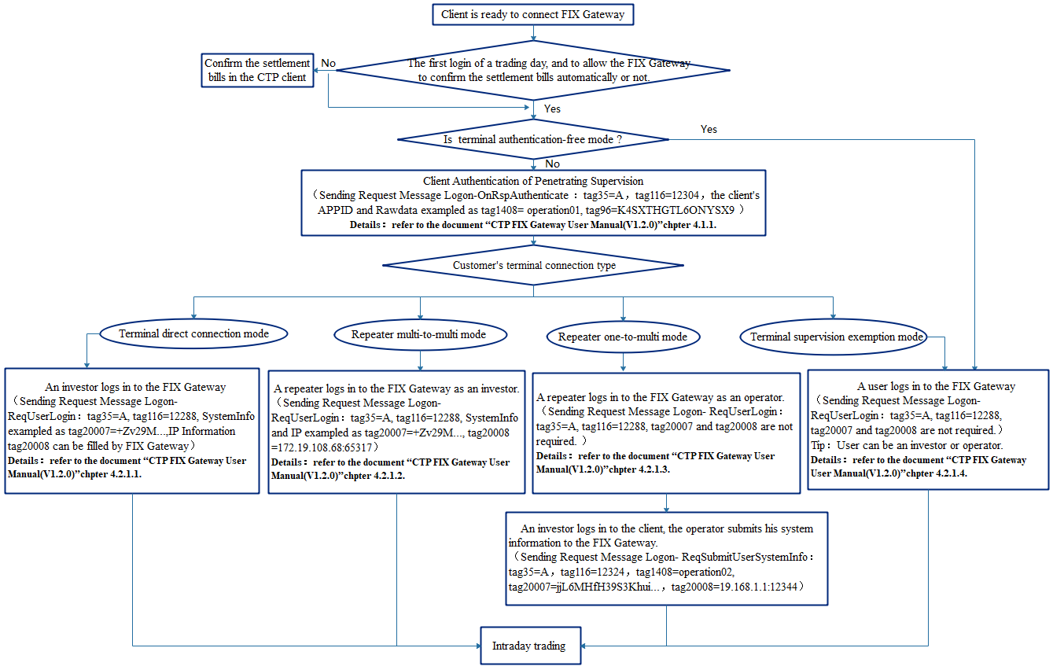

Figure 3

## 4.1 Client Authentication of Penetrating Supervision (except for FIX market data Gateway)

Before logging in to the FIX Gateway, terminal direct connection mode, repeater multi-to-multi mode, repeater one-to-multi mode and terminal exemption mode all need to send authentication request messages with the same format. The tag1408-DefaultCstmApplVerID field should be filled with the AppID of the client terminal and the tag96-RawData field should be filled with the authentication code of the client. These two fields are required. In terminal authentication-free mode, the investor can login directly without sending authentication request messages. The following is an example of the processing of the system:

### 4.1.1 Common situation（tag141-ResetSeqNumFlag is null or value is 'N'.）

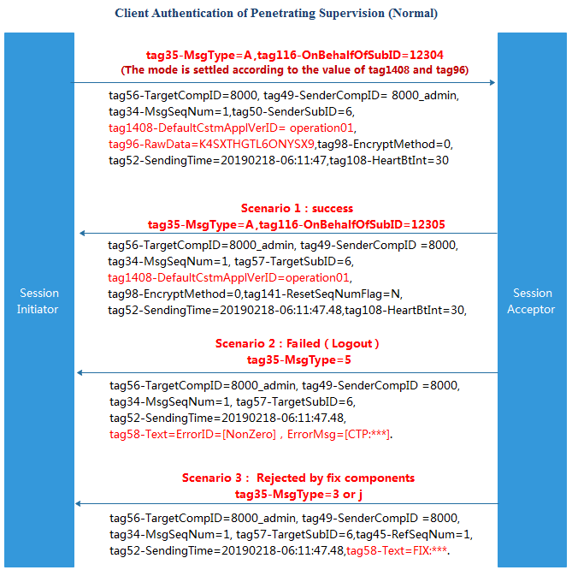

Figure 4

### 4.1.2 Client applies for sequence reset (succeed or fail)

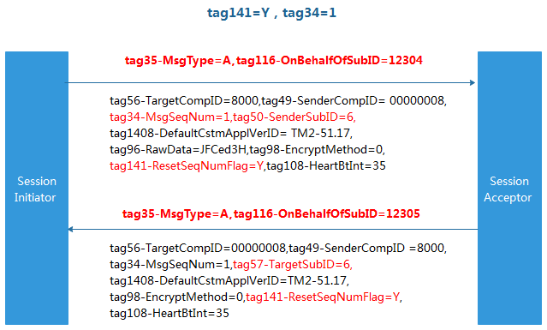

Figure 5

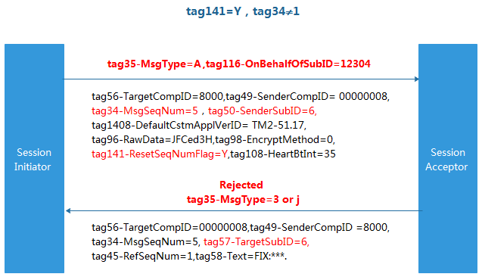

Figure 6

## 4.2 Penetrating Supervision Login (except for FIX market data Gateway)

### 4.2.1 Common login situation under different modes（tag141-ResetSeqNumFlag is null or value is 'N'.）

#### 4.2.1.1 Terminal direct connection mode login

For the terminal direct connection login mode, when each investor logs in to the FIX Gateway, the login message needs to be filled with tag20007-ClientSysInfo (terminal information collected), while tag20008-ClientPublicIP (The IP address and port number of the client terminal, separated by a colon in the middle) can be filled by the FIX Gateway.

The detailed flow chart is as follows:

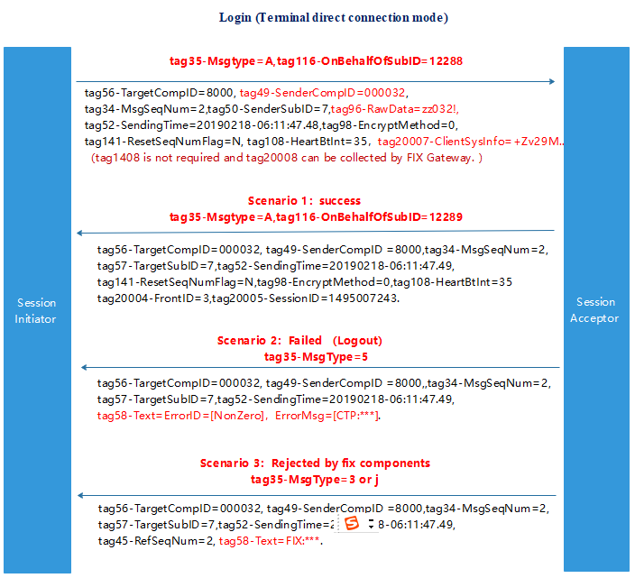

Figure 7

#### 4.2.1.2 Repeater multi-to-multi mode login

For the repeater multi-to-multi login mode, when each repeater logs in to the FIX Gateway as an investor, the login message needs to be filled with the following fields:

* tag1408-DefaultCstmApplVerID (which stores the AppID of the client terminal)
* tag20007-ClientSysInfo (terminal information collected)
* tag20008-ClientPublicIP (The IP address and port number of the client terminal, separated by a colon in the middle);

The detailed flow chart is as follows:

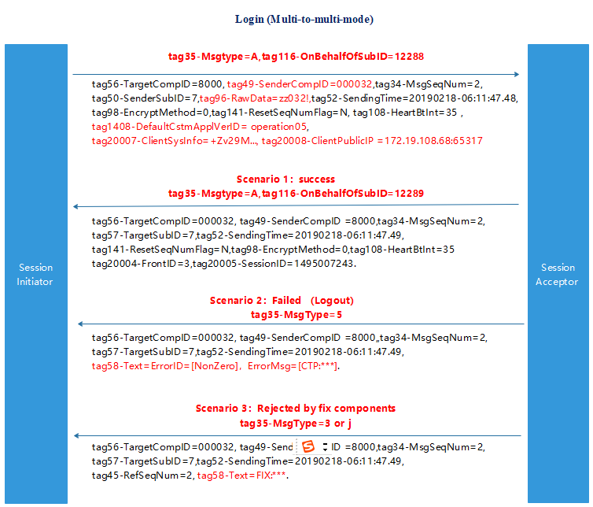

Figure 8

#### 4.2.1.3 Repeater one-to-multi mode login

For the repeater one-to-multi login mode, the tag20007 and tag20008 fields in the login message are not required when the repeater logs in to the FIX Gateway as an operator. The detailed flow chart is as follows:

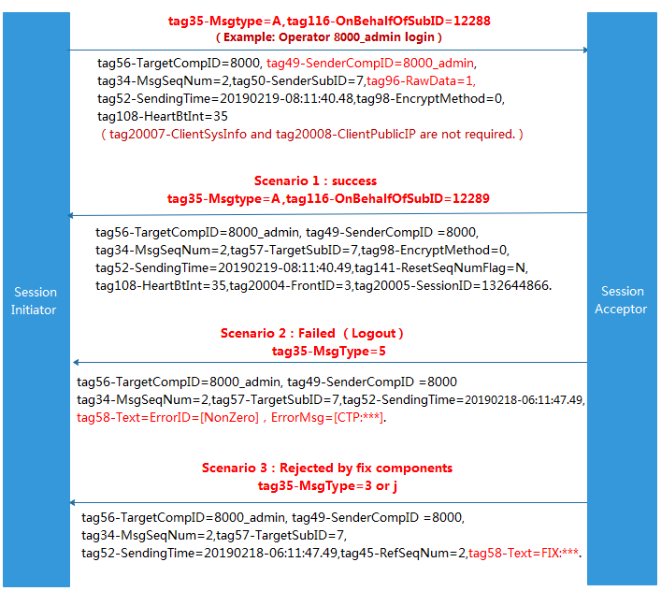

Figure 9

After the operator logs in to the FIX Gateway, when an investor managed by him logs in to the terminal, the operator needs to send a ReqSubmitUserSystemInfo message (tag35=A, tag116-OnBehalfOfSubID=12324) to the FIX Gateway. After receiving the terminal information, the FIX Gateway forwards it to the CTP backend and reports it to the regulatory authority. The tag20007, tag20008, and tag1408 fields in the message are required fields, and tag1408-DefaultCstmApplVerID (which stores the AppID of the client terminal) can be encoded by the operator system, and the FIX Gateway does not verify.

The detailed flow chart is as follows:

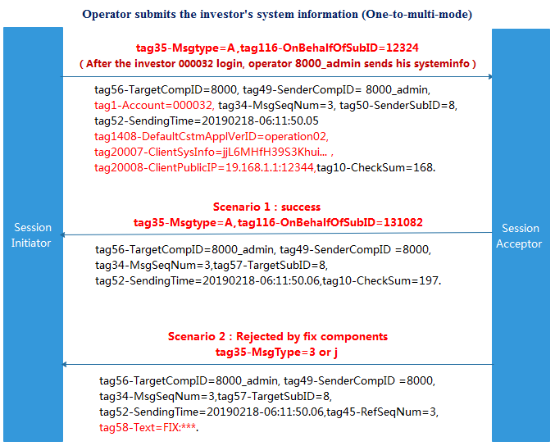

Figure 10

#### 4.2.1.4 Terminal supervision exemption mode or terminal authentication-free mode

In the terminal supervision exemption mode or the terminal authentication-free mode, when users log in to FIX Gateway, the tag20007 and tag20008 fields in the login messages are not required.

The detailed flow chart is as follows:

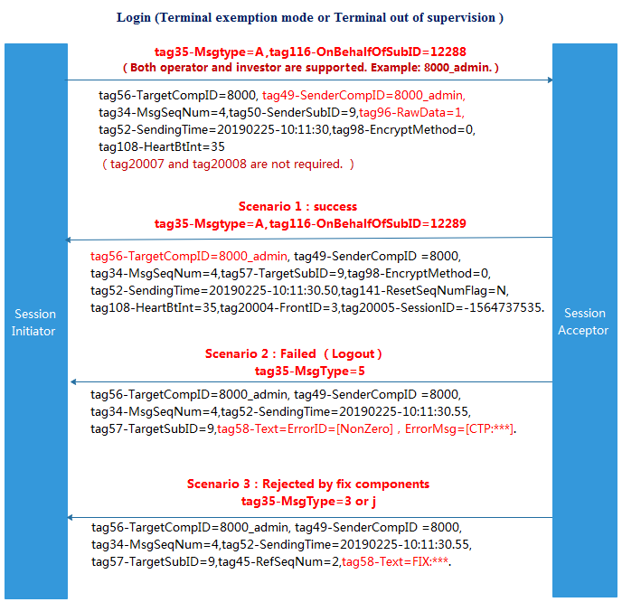

Figure 11

### 4.2.2 Client applies for sequence reset (succeed or fail)

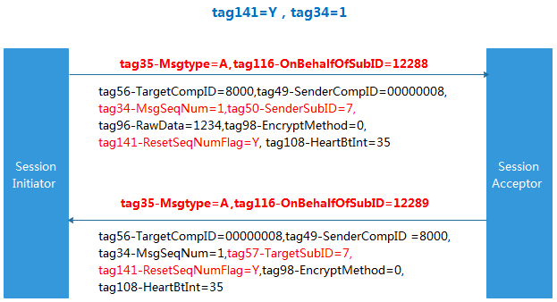

Figure 12

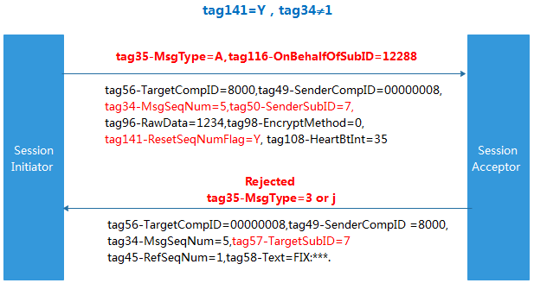

Figure 13

### 4.2.3 Tag34-MsgSeqNum in the message is too high

The client can still log in the system when the value of tag34 in the request message is higher than the one expected by the FIX Gateway. The FIX Gateway will request the client to resend those messages whose values of tag34 are lower than the one in the login message. (The begin and the end sequence number of the resending messages can be specified. Moreover, only messages of the business layer will be resent.)

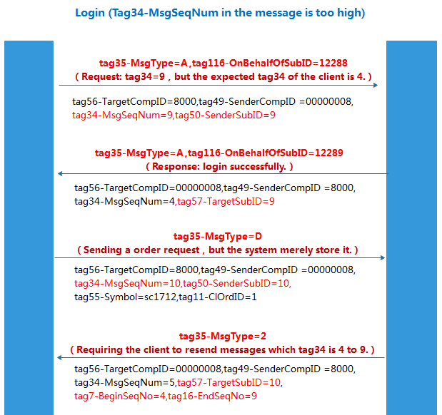

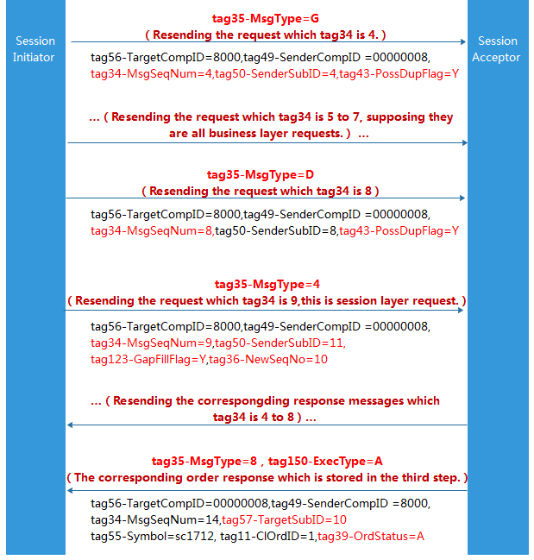

Figure 14

## 4.3 Logout

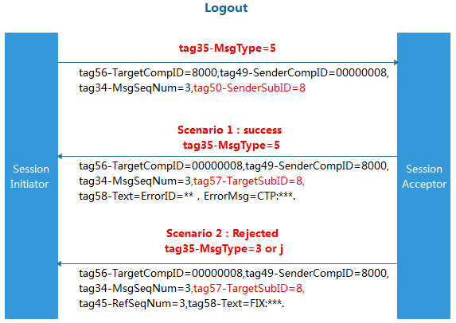

Figure 15

## 4.4 Password Update

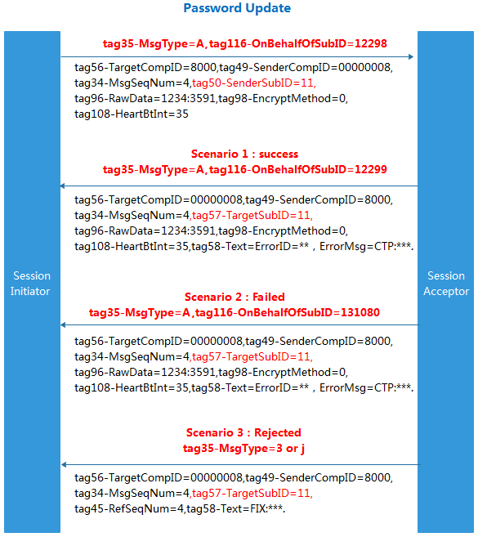

Figure 16

## 4.5 Test Request

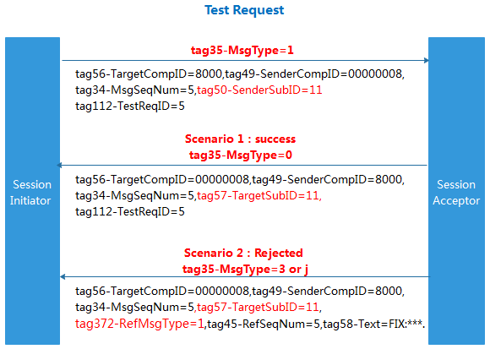

Figure 17

## 4.6 Resend Request

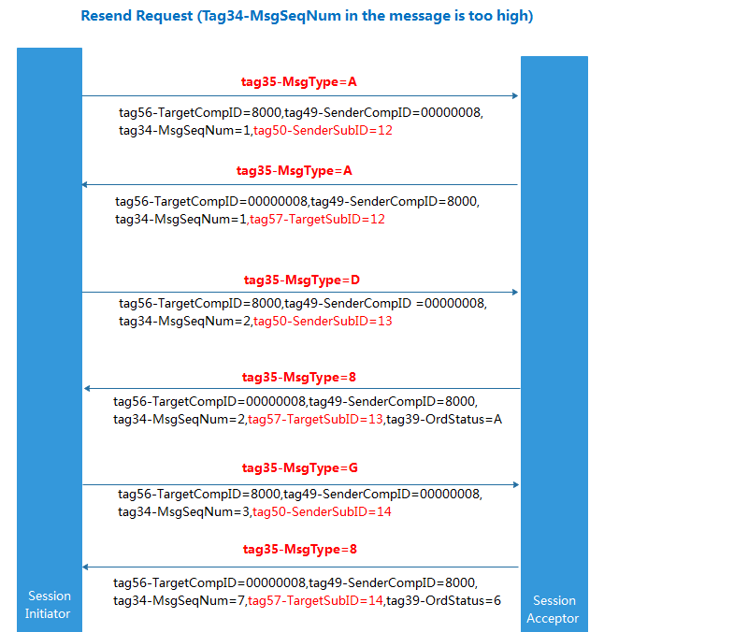

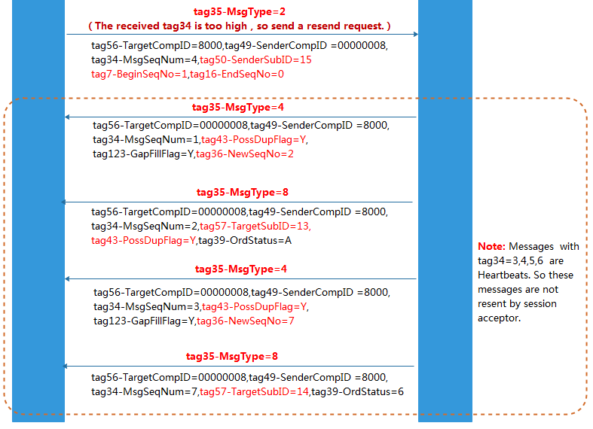

Figure 18

# 5、Business Layer

## 5.1 NewOrderSingle

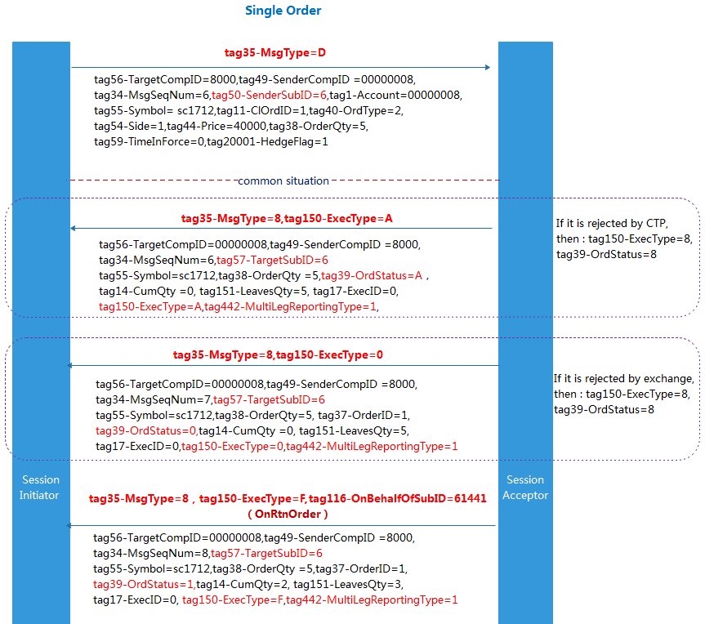

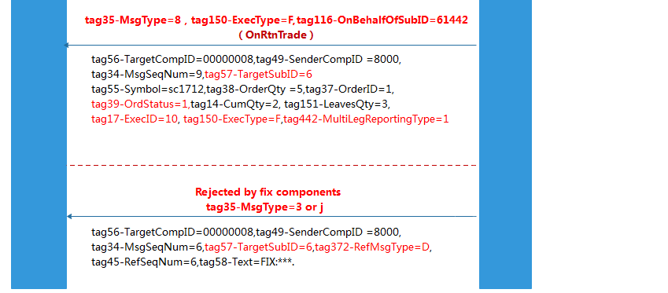

Figure 19

Note：

1. For an order request, if the successful message is returned from the CTP, then tag35-MsgType=8, tag39-OrdStatus=A, tag150-ExecType=A.
2. For an order request, if the rejected message is returned from the CTP or the Exchange, then tag35-MsgType=8, tag39-OrdStatus=8, tag150-ExecType=8.
3. For an order request, if the successful message is returned from the Exchange, then tag35-MsgType=8, tag39-OrdStatus=0, tag150-ExecType=0.
4. For an order request, if the message is a trade response from the Exchange, then tag35-MsgType=8, tag39-OrdStatus=1 or 2, tag150-ExecType=F, tag116-OnBehalfOfSubID=61441.
5. For an order request, if the message is a trade order from the Exchange, then tag35-MsgType=8, tag39-OrdStatus=1 or 2, tag150-ExecType=F, tag116-OnBehalfOfSubID=61442.
6. For a request, if the message is rejected by the FIX component, then tag35-MsgType=3 or j, tag372-RefMsgType=D.

### 5.1.1 NewOrderSingle: Non-split

The parameter ReverseOpen is set to 1 in FIXfront_mt.ini. For order requests, the following chart indicates the system processes when the tag77-OpenClose is null.

* Example 1：Initially, an investor holds 5 hands of historical short position of sc1712. During trading time, the investor sends an order to buy 4 hands of sc1712. Since 5>4, the FIX Gateway will treat it as a close position order of buying 4 hands.
* Example 2：Initially, an investor holds 5 hands of historical short position of sc1712. During the trading time, the investor sends an order to buy 10 hands of sc1712. Since 5<10, the FIX Gateway will treat it as an open position order of buying 10 hands.
* Example 3：Initially, an investor holds a short today’s position of 5 hands of sc1712 and a short historical position of 5 hands of sc1712. During the trading time, the investor sends an order to buy 8 hands of sc1712. Since 8<(5+5), the FIX Gateway will divide this order into 2 parts, one is a close historical position order of buying 5 hands, the other is a close today’s position order of buying 3 hands. 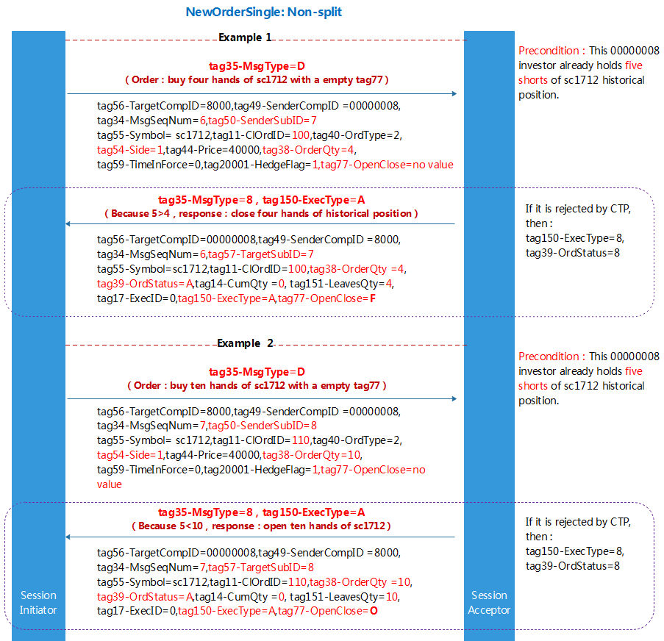

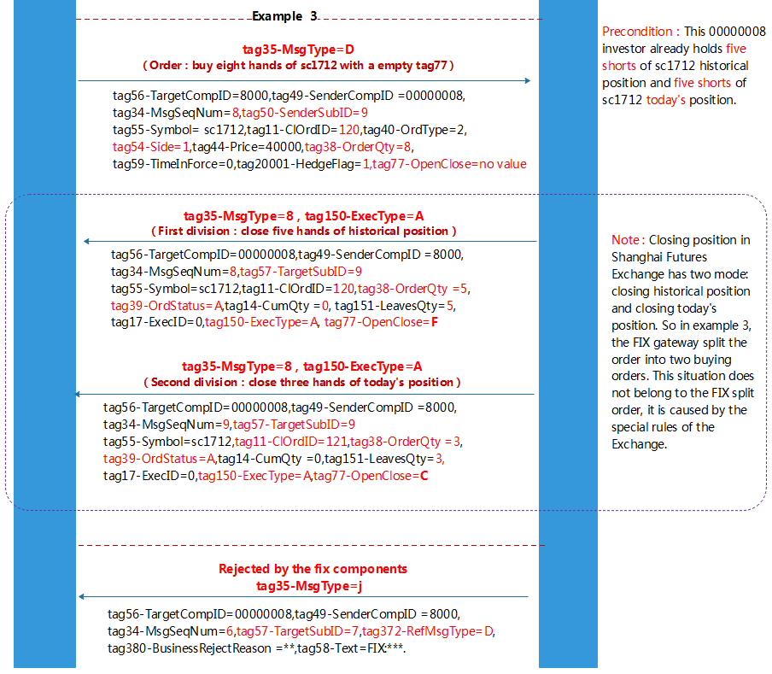

Figure 20

### 5.1.2 NewOrderSingle: Split

The parameter ReverseOpen is set to 0 in FIXfront_mt.ini. For order requests, the following chart indicates the system processes when the tag77-OpenClose is null:

* Initial state: the investor has three shorts of sc1712 historical position, two shorts of sc1712 today position.
* The investor’s order: buy ten hands of sc1712, price limit order, and the tag77-OpenClose is null.
* System processes：According to the actual situation of this investor, this order is split into three orders. They are three hands of closing yesterday's position, two hands of closing today's position, five hands of opening a long position, respectively.

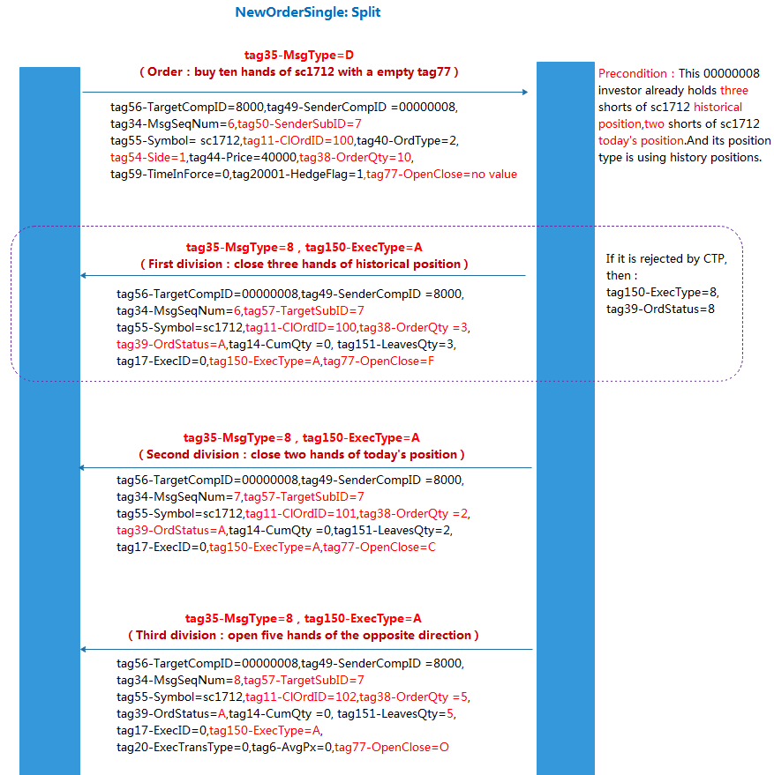

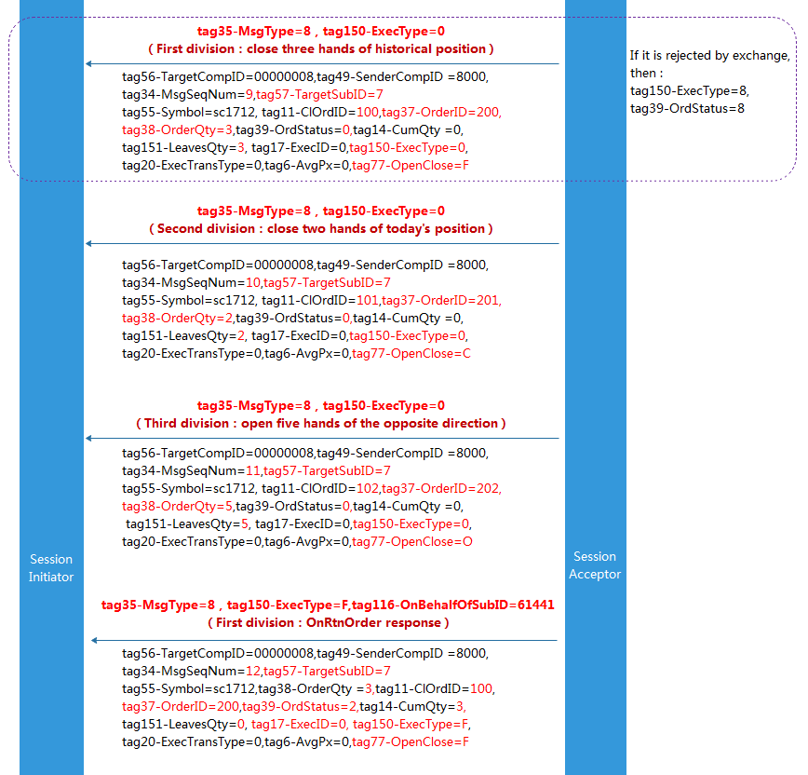

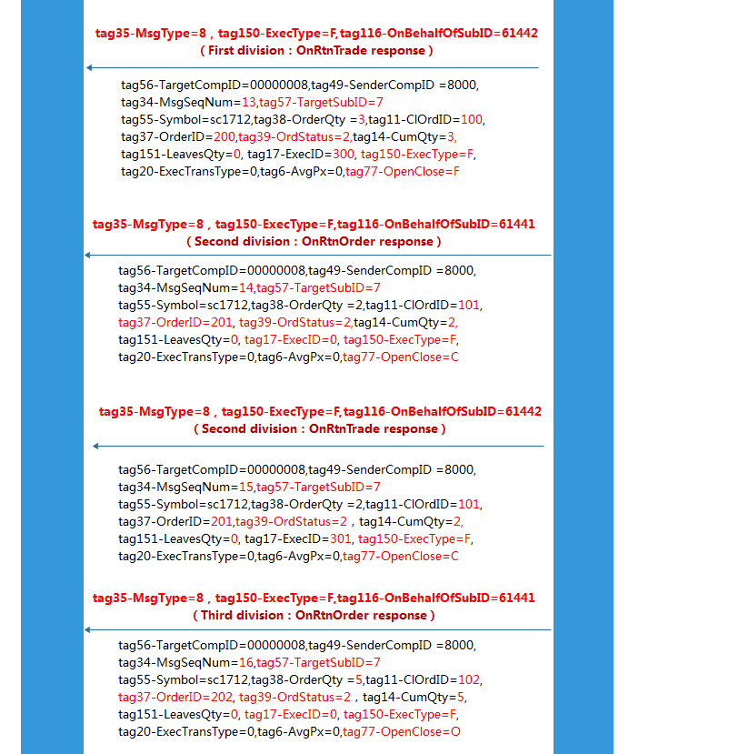

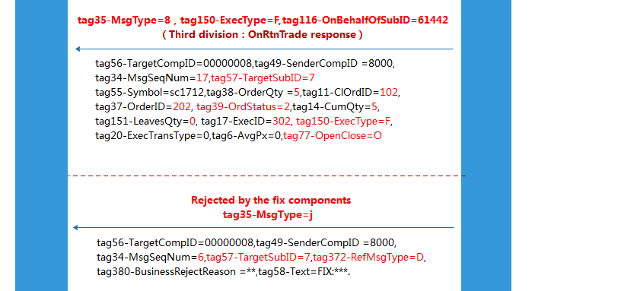

Figure 21

## 5.2 OrderCancelRequest

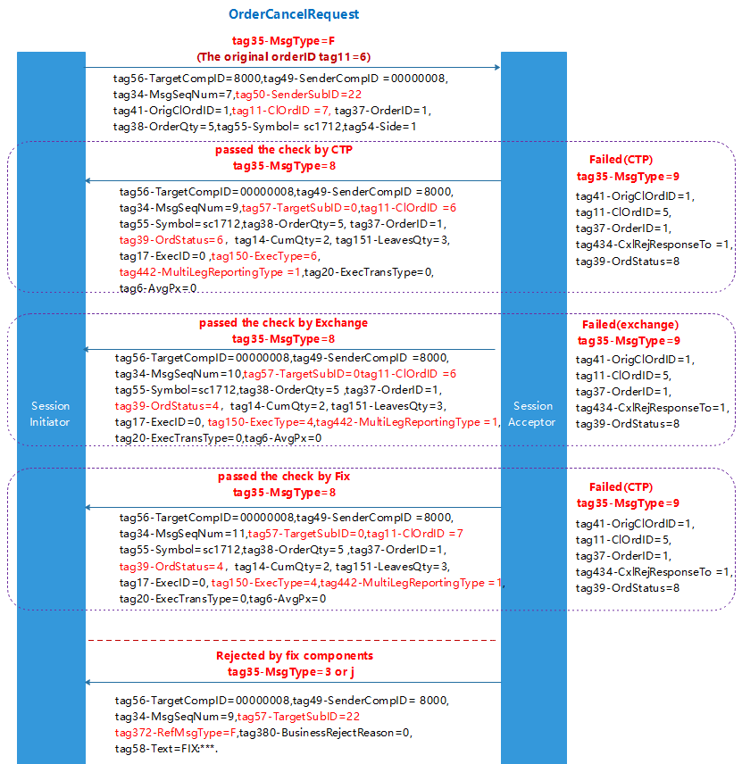

Figure 22

Note：

1. For a cancelling order, if the successful message is returned from the CTP, then tag35-MsgType=8, tag39-OrdStatus=6, tag150-ExecType=6.
2. For a cancelling order, if the message is rejected by the CTP or the Exchange then tag35-MsgType=9, tag39-OrdStatus=8.
3. For a cancelling order, if the successful message is returned from the Exchange, then tag35-MsgType=8, tag39-OrdStatus=4, tag150-ExecType=4.
4. For a cancelling order, if the message is rejected by the FIX component, then tag35-MsgType=3 or j, tag372-RefMsgType=F.
5. If you need to cancel an order, tag11-ClOrdID, tag20004-FrontID and tag20005-SessionID can be used to identify the order and cancel it. The order can also be identified and cancelled according to the tag37-OrderID and tag207-SecurityExchange.
6. If the Order Cancel Request succeed, two messages will be returned: one is from the CTP with tag11-ClOrdID equals the tag11-ClOrdID of the original order-reference, the other is from the FIX with tag11-ClOrdID equals the tag11-ClOrdID of the OrderCancelRequest message.

## 5.3 OrderCancelReplaceRequest

The investor is only allowed to change the price or the volume of an order. Cancel/Replace order in the CTP is actually a process of cancelling the older order and then starting a new one. It is mainly because the Exchange does not support the direct replace order. For a cancel replace order, only the response of the cancelling order and the resending order are returned, no replace order response will be returned.

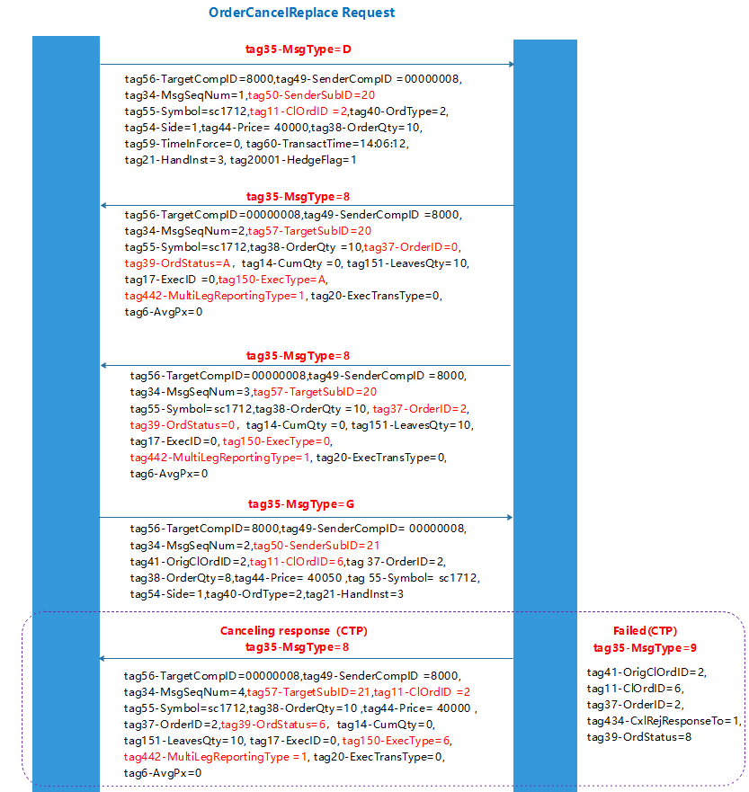

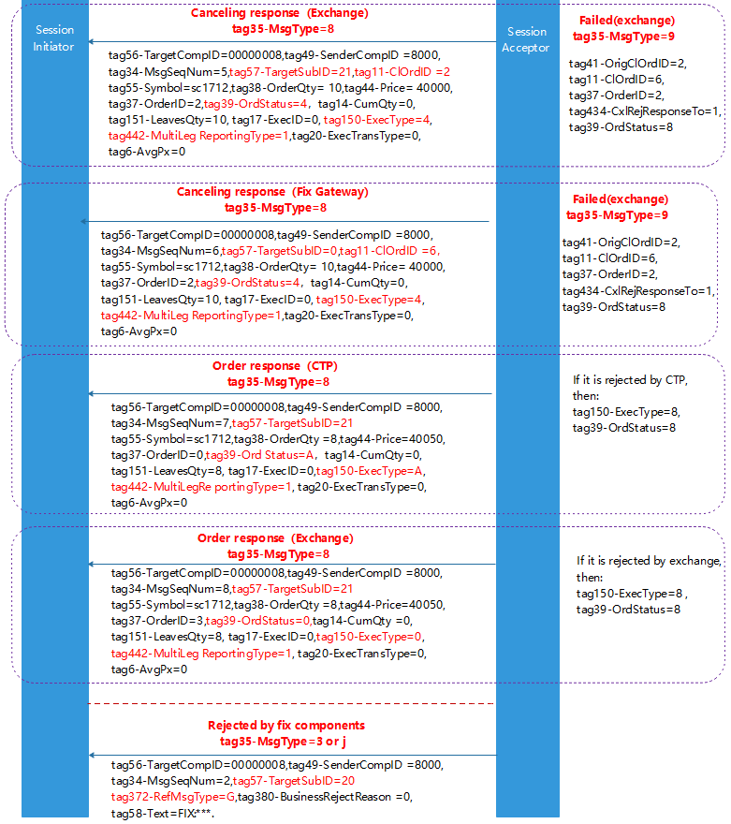

Figure 23

## 5.4 OrderStatusRequest

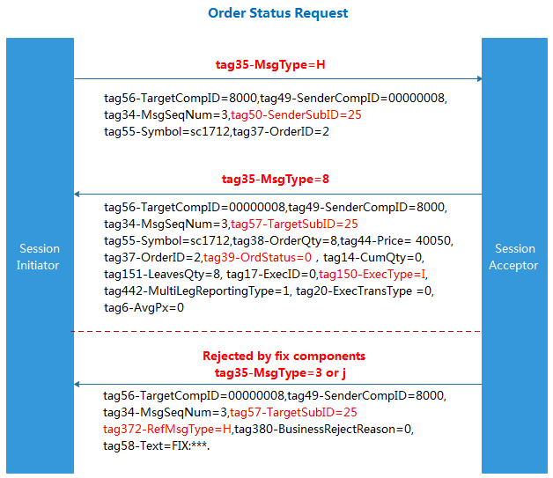

Figure 24

## 5.5 SecurityDefinitionRequest

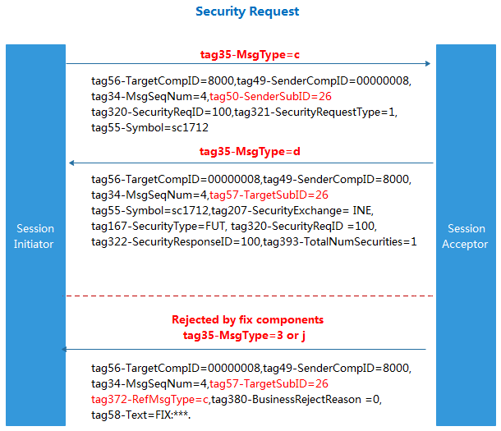

Figure 25

## 5.6 [MultilegOrders](javascript:expand('MultilegOrders');)

The Chinese exchanges’ business rules of combination order is different from other countries. Currently, only CFFEX and DCE support this business rule and each combination has a CombInstrumentID with no single leg contract details. The domestic combination contract format is A&B. A and B are single InstrumentIDs, respectively. For example: IF1706 & IF1712.

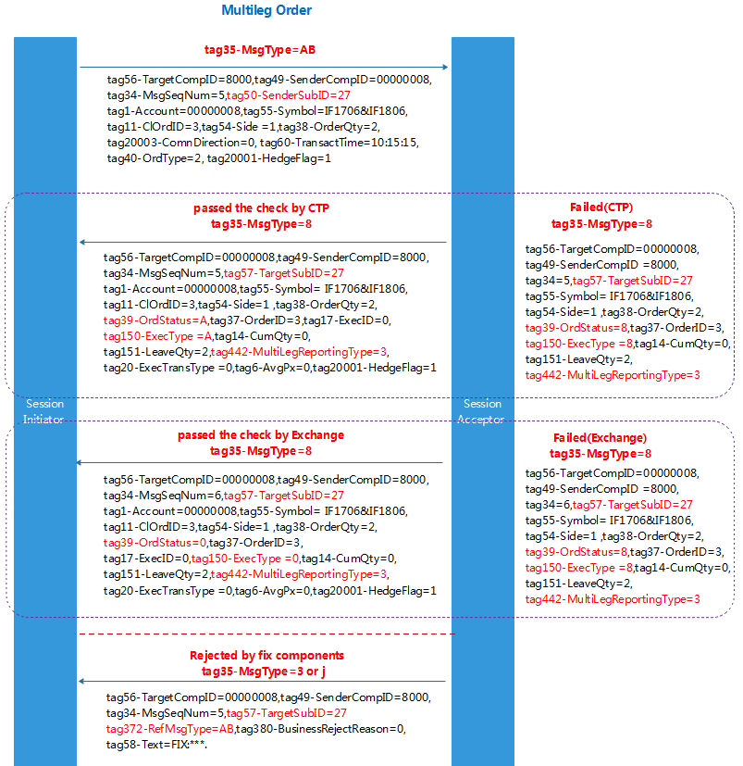

Figure 26

Note：

1. For a combination order, if the successful message is returned from the CTP, then tag35-MsgType=8, tag39-OrdStatus=A, tag150-ExecType=A.
2. For a combination order, if the message is rejected by the CTP or the Exchange, then tag35-MsgType=8, tag39-OrdStatus=8.
3. For a combination order, if the successful message is returned from the Exchange, then tag35-MsgType=8, tag39-OrdStatus=0, tag150-ExecType=0.

## 5.7 MarketDataRequest

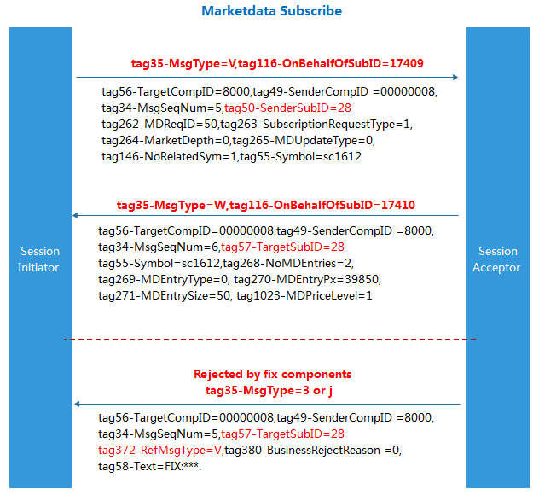

Figure 27

Note：

1. When the investor subscribes market data, the market data information (tag35-MsgType=W) is returned afterwards.
2. When the investor subscribes market data, if the FIX component rejects the request, then tag35-MsgType=3 or j, tag372-RefMsgType=V in the return message.

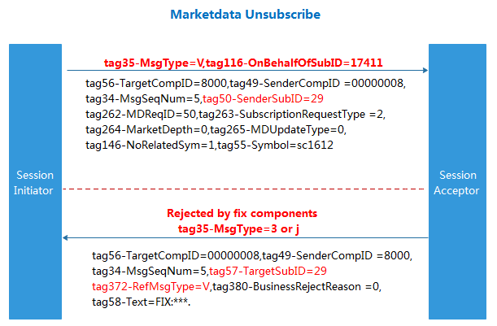

Figure 28

Note：

1. When the investor unsubscribes market data, no information is returned.
2. When the investor unsubscribes market data, if the FIX component rejects the request, then tag35-MsgType=3 or j, tag372-RefMsgType=V in the return message.

## 5.8 MassQuote

Market makers can make option quotes as follows:

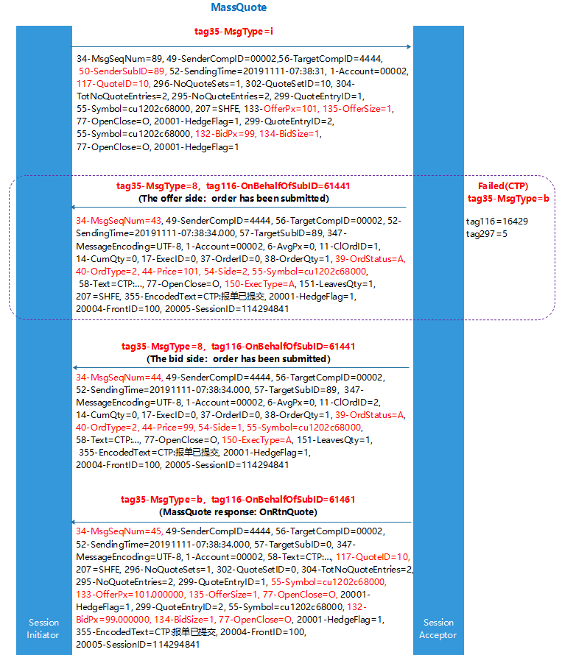

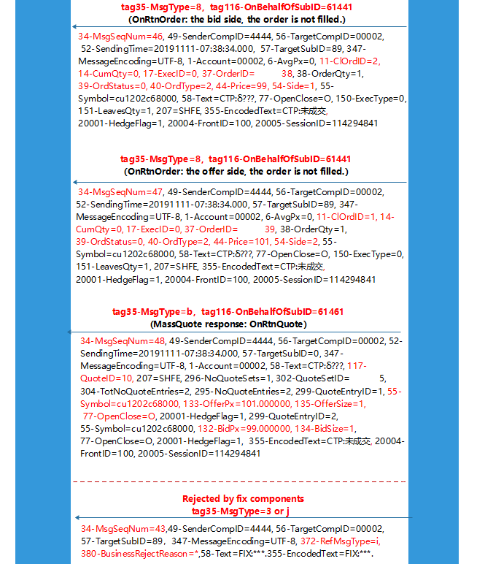

Figure 29

Note：

1. If the MassQuote request is successful, 6 messages will be returned: (1) Four Order Notice with

tag35 msgtype=8 and tag116 onbehalfofsubid=61441, two returns for each side of the transaction; (2) Two Quote Return with tag35 msgtype = B and tag116 onbehalfofsubid = 61461.

1. If the MassQuote request is rejected by the Exchange, message returned is tag35 msgtype=B, tag116 onbehalfofsubid =16429.
2. If the MassQuote request is rejected by the FIX, message returned is tag35 msgtype=3 or j.

## 5.9 QuoteCancel

Investors can cancel the option MassQuote reported to the Exchange, and the quotation can be identified by tag117-QuoteID, tag20004-FrontID and tag20005-SessionID.

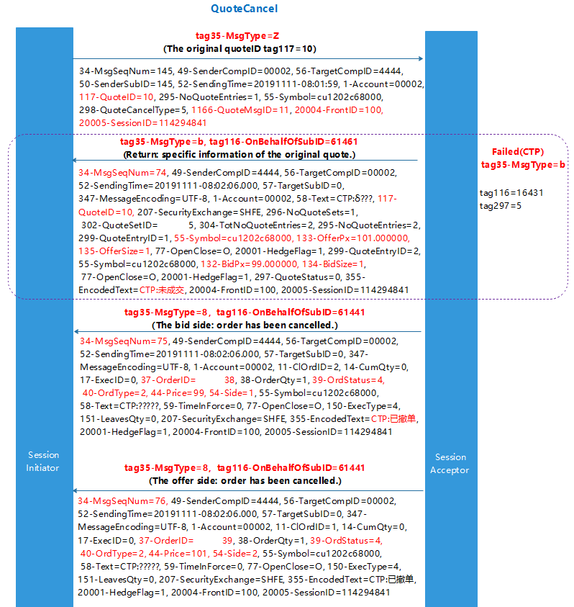

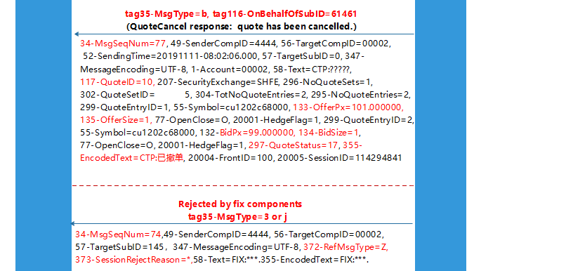

Figure 30

Note：

1. When sending a QuoteCancel request, if the request is successful, 3 messages is returned: (1) First return is about the basic information of the quotation to be cancelled with tag35 msgtype=B and tag116 onbehalfofsubid=61461. (2)Second return is the Order Cancellation Return of the bid/ask price with tag35 msgtype =8, tag116 on behalfofsubid=61441. (3)Third return is the Quote Cancelled return with tag35 msgtype=B, tag116 on behalfofsubid=61461.
2. If the QuoteCancel request is rejected by the Exchange, message returned is tag35-MsgType=b, tag116-OnBehalfOfSubID=16431, tag297- QuoteStatus=5.
3. If the QuoteCancel request is rejected by the FIX, message returned is tag35 msgtype=3 or j.

## 5.10 QuoteRequest

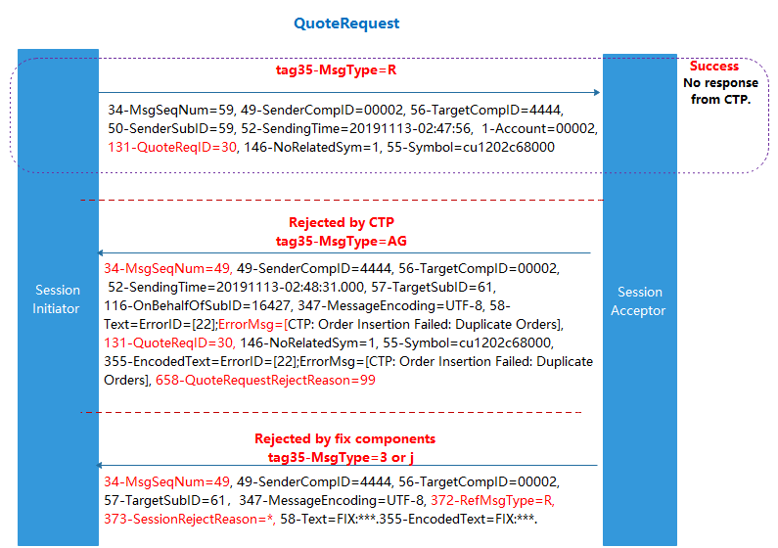

Figure 31

Note：

1. If the QuoteRequest request is successfully sent, no response message will not be returned.
2. If the QuoteRequest is rejected by the Exchange, message returned is tag35-MsgType=AG.
3. If the QuoteRequest is rejected by the FIX, message returned is tag35 msgtype=3 or j.

## 5.11 NewOrderSingle-OptionSelfClose

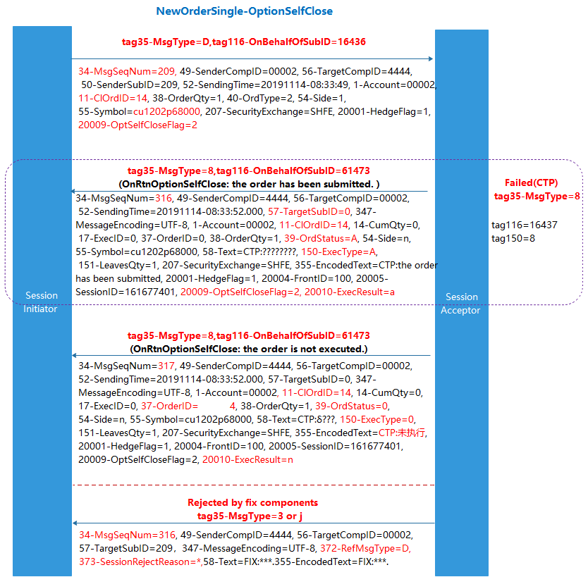

Figure 32

## 5.12 OrderCancelRequest-OptionSelfCloseAction

The OptionSelfCloseAction can be used by the investor to cancel the OptionSelfClose order reported to the Exchange. The original OptionSelfClose order can be identified by the combination of tag41-OrigClOrdID、tag20004-FrontID and tag20005-SessionID, or by tag37-OrderID and tag207-SecurityExchange.

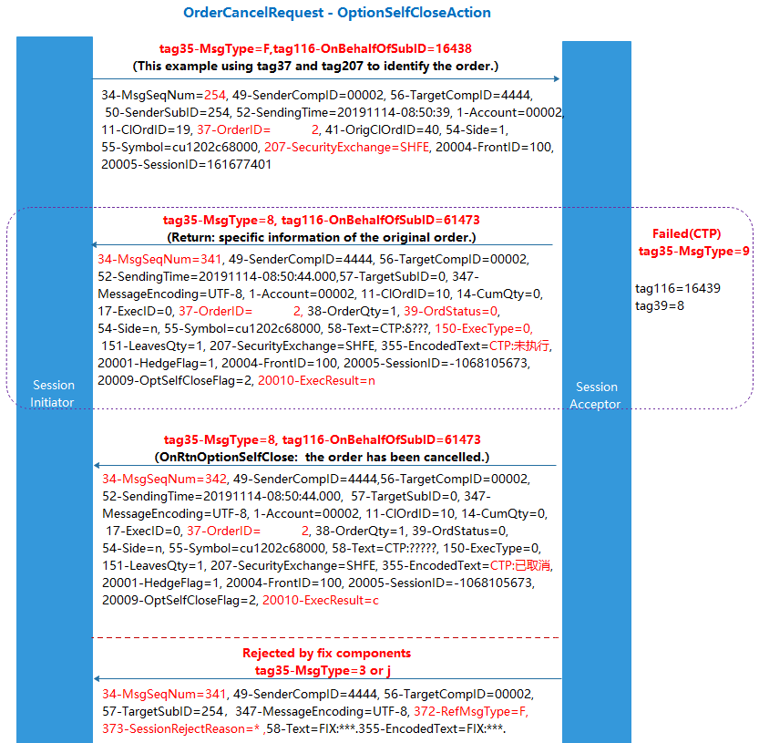

Figure 33

Note：

1. When sending the OptionSelfCloseAction, if the request is successful, 2 messages are returned, both with tag35 msgtype=8 and tag116 onbehalfofsubid = 61473.
2. If the OptionSelfCloseAction is rejected by the Exchange, message returned is tag35-MsgType=9 and tag116-OnBehalfOfSubID=16439.
3. If the OptionSelfCloseAction is rejected by the FIX, message returned is tag35 msgtype=3 or j.

## 5.13 PositionMaintenanceRequest-ExecOrderInsert

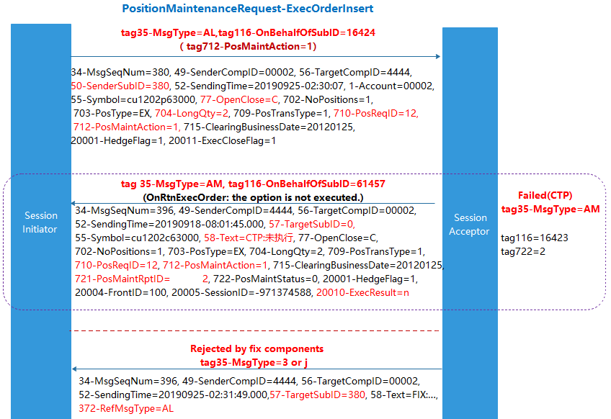

Figure 34

Note：

1. When sending the ExecOrderInsert request, if the request is successful, it will return: ag35-MsgType=AM and tag116-OnBehalfOfSubID=61457.
2. If the ExecOrderInsert request is rejected by the Exchange, message returned is tag35-MsgType=AM， tag116-OnBehalfOfSubID=16423.
3. If the ExecOrderInsert request is rejected by the FIX, message returned is tag35 msgtype=3 or j.

## 5.14 PositionMaintenanceRequest-ExecOrderAction

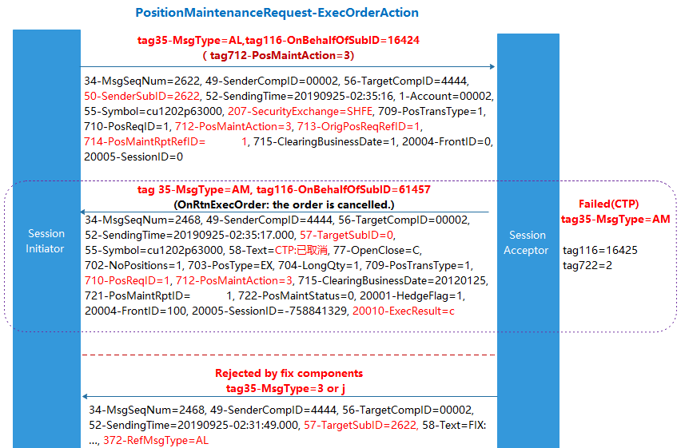

Figure 35

Note：

1. When sending the ExecOrderAction request, if the request is successful, it will return: tag35-MsgType=AM，tag116-OnBehalfOfSubID=61457.
2. If the ExecOrderAction request is rejected by the Exchange, message returned is tag35-MsgType=AM， tag116-OnBehalfOfSubID=16425.
3. If the ExecOrderAction request is rejected by the FIX, message returned is tag35 msgtype=3 or j.

## 5.15 QuoteStatusRequest

Investors can use QuoteStatusRequest to subscribe to or unsubscribe the QuoteRequest of any contract. If the QuoteStatusRequest of a contract is successfully sent, the investor can receive the QuoteRequest message for this contract sent by other investors in the market to the Exchange.

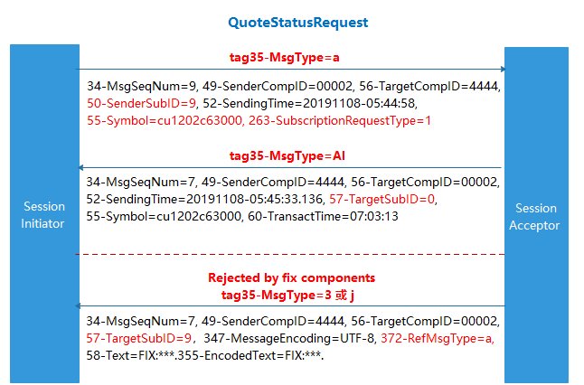

Figure 36

1. The corresponding Error information: 58=ErrorID = [140]; ErrorMsg = [CTP: First login, please change the password and login again]
2. The corresponding Error information: 58=ErrorID = [141]; ErrorMsg = [CTP: Expired password, please change it and login]
3. The corresponding Error information: 58=ErrorID = [131]; ErrorMsg = [CTP: Weak password is expired, please change it and login]